Лабораторная работа
Кривая Гильберта

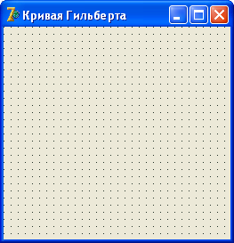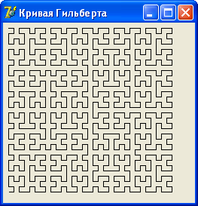

unit gilbert_;
interface
uses
Windows, Messages, SysUtils, Variants, Classes, Graphics, Controls, Forms,
Dialogs, StdCtrls, ComCtrls;
type
TForm1 = class(TForm)
procedure FormPaint(Sender: TObject);
private
{ Private declarations }
public
{ Public declarations }
end;
var
Form1: TForm1;
implementation
{$R *.dfm}
var
p: integer = 5; // порядок кривой
u: integer = 7; // длина штриха
{ Кривая Гильберта состоит из четырех соединенных прямыми элементов. }
procedure a(i:integer; canvas: TCanvas); forward;
procedure b(i:integer; canvas: TCanvas); forward;
procedure c(i:integer; canvas: TCanvas); forward;
procedure d(i:integer; canvas: TCanvas); forward;
// элементы кривой
procedure a(i: integer; canvas: TCanvas);
begin
if i > 0 then begin
d(i-1, canvas); canvas.LineTo(canvas.PenPos.X+u,canvas.PenPos.Y);
a(i-1, canvas); canvas.LineTo(canvas.PenPos.X,canvas.PenPos.Y+u);
a(i-1, canvas); canvas.LineTo(canvas.PenPos.X-u,canvas.PenPos.Y);
c(i-1, canvas);
end;
end;
procedure b(i: integer; canvas: TCanvas);
begin
if i > 0 then
begin
c(i-1, canvas); canvas.LineTo(canvas.PenPos.X-u,canvas.PenPos.Y);
b(i-1, canvas); canvas.LineTo(canvas.PenPos.X,canvas.PenPos.Y-u);
b(i-1, canvas); canvas.LineTo(canvas.PenPos.X+u,canvas.PenPos.Y);
d(i-1, canvas);
end;
end;
procedure c(i: integer; canvas: TCanvas);
begin
if i > 0 then
begin
b(i-1, canvas); canvas.LineTo(canvas.PenPos.X,canvas.PenPos.Y-u);
c(i-1, canvas); canvas.LineTo(canvas.PenPos.X-u,canvas.PenPos.Y);
c(i-1, canvas); canvas.LineTo(canvas.PenPos.X,canvas.PenPos.Y+u);
a(i-1, canvas);
end;
end;
procedure d(i: integer; canvas: TCanvas);
begin
if i > 0 then
begin
a(i-1, canvas); canvas.LineTo(canvas.PenPos.X,canvas.PenPos.Y+u);
d(i-1, canvas); canvas.LineTo(canvas.PenPos.X+u,canvas.PenPos.Y);
d(i-1, canvas); canvas.LineTo(canvas.PenPos.X,canvas.PenPos.Y-u);
b(i-1, canvas);
end;
end;
procedure TForm1.FormPaint(Sender: TObject);
begin
Form1.Canvas.MoveTo(u,u);
a(5,Form1.Canvas); // вычертить кривую Гильберту
end;
end.

